Q1

1. 24
2. 10
3. Compilation error (if def ing)
4. Compilation error
6. Due to “%d” address is(-429368736)
7. 10

Q2

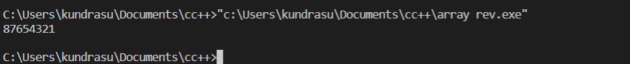

Q3

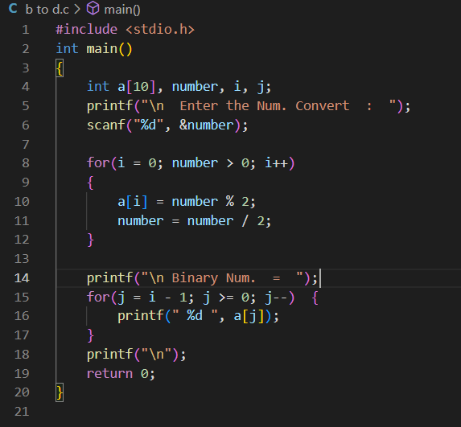

Q4

1. False
2. False

Q5

False

Q6

